MAD & DIVINE
The Natya Darshan Daily
December 26, 2011
Kartik Fine Arts & Arangham Trust  Present seminar and performances on  ‘Mystic women saint poets of India & beyond’  Convener: Dr. Anita Ratnam | 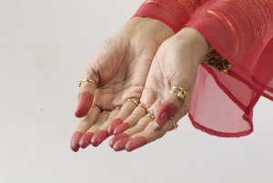 | Bharatiya Vidya Bhavan, Chennai  23 - 25 December 2011  10am to 1pm
“One sees nothing, either within or without, but while seeing nothing the soul understands quite clearly who it is and where it is and sometimes even what he means to tell it. How and by what means it understands it does not know, but so it is, & while this is happening it cannot fail to know it.”  - St. Teresa of Avila  REVIEWS  Maddening paradoxes & divine connections  - Kiran Rajagopalan  The concluding day of ‘Mad and Divine’ was filled with activity as the legendary Dr. Vyjayanthimala Bali was honored with a lifetime achievement award from Kartik Fine Arts alongside the usual morning performance and lectures. Much to everyone’s delight, Dr. Bali also gave a surprise performance of a charming verse from Leela Shukar’s Sri Krishnakarnamrutham in which a gopi questions Krishna about stealing butter from her house.  Dr. Vyjayanthimala Bali  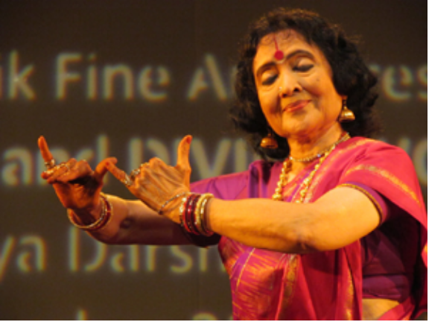  Prior to the award ceremony, Chitra Visweswaran presented a simple, but deeply touching portrayal of Mirabai as an older woman pensively reflecting on the pivotal decisions she had made during her life. Notable episodes such as her brother-in-law’s attempts to poison her were dramatically enacted with an underlying sense of melancholy. However, Chitra eventually transformed that melancholy into profound longing for Krishna, and the fervent Mirabai finally emerged at the end of the piece.  While most of the conference focused on women from the past, film-maker Madhureeta Anand led a session on sadhvis, the modern-day mystic women of India. She interviewed a remarkable Swedish woman named Uma, a nagasadhvi who has lived as an ascetic in India for several decades. Uma cleared several major misconceptions about ascetics such as the notion that they are all learned people who have mastered the sacred Hindu texts. In fact, many members of her sect are simple folk from disadvantaged backgrounds.  Madhureeta Anand    Uma then revealed another disconcerting reality: there is a certain degree of patriarchy and casteism in her Shaivite sect. As a casteless, foreign woman, she was relegated to years of sweeping, scrubbing pots, and silent observation before being fully initiated into the sect. Sadly, these ascetic sects are now becoming diluted because of these caste and gender issues along with the proliferation of spurious “spiritual gurus.”  Dr. Ketu Katrak also touched upon the inherent paradox of mystic women in her final plenary session. Despite being fiercely independent and outside of society’s conventions, the mystic saint-poetesses all yearned for a | male deity! Following this discussion were the final  lectures of the conference by Nirupama Vaidhyanathan Dr. Pallabi Chakravorty and Dr. Scott Kugle. Nirupama carefully examined the parallel lives of Mirabai and the Spanish catholic saint, Theresa of Avila. Interestingly, Mirabai and St. Theresa lived during the same time period and faced similar discrimination for their dissent against the Rajput patriarchy and the Catholic Church, respectively. However, St. Theresa’s works and life story were carefully preserved for posterity. In contrast, many aspects of Mirabai’s life remain shrouded in uncertainty, but India’s strong oral tradition has kept her poetry alive.  Pallabi Chakravorty and Scott Kugle then spoke about the influence of the bhakthi and Sufi traditions in the works of Mirabai and Mah Laq Bai (a famous Hyderabadi courtesan from the late 18th-century CE). Stirring music and dance are key elements in both traditions, and they are powerful mediums through which a person can reach out to their “beloved.” Surprisingly, Krishna was the sole object of devotion and affection in Mirabai’s bhajans and Mah Laq Bai’s thumris!  Overall, the morning sessions of this conference were extremely informative and engaging because of the diversity of presenters and topics discussed. Dr. Anita Ratnam must be commended for skillfully organizing and managing this conference. Special mention must also be made of all the individuals who worked tirelessly behind the scenes to make this conference so seamless. Let’s see what pleasant surprises Anita Ratnam has in store for Chennai’s rasikas in next year’s conference!  *****  Madness matters!  - Pratima Sagar  The concluding performances of the evening left the audiences asking for more… the euphoria left by Rama Vaidyanathan who danced to “soulful Abhangs and thoughtful Vakhs” for the season’s theme of mystic saint poets, gave way to the next year’s idea on ‘Epic women…’  Soulful, sprightly and spiritual  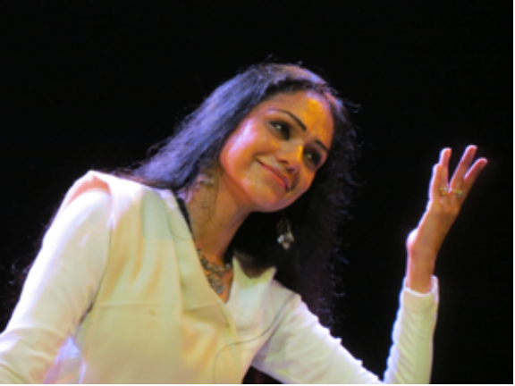  Rama Vaidyanathan struck the right chord taking the dance festival to a crescendo. She truly showed the “joys” of being “mad and divine” and how! “Utto pandu ranga” – when the danseuse danced with a childlike innocence and madness as she talked, chided and placated her lord, she became the saint Janabai. And in another “parama shivo tantara…” she became the mystic Lalleswari who shed shame, desire and the world itself… for she is now “jeevan mukta” or the liberated one - one with Shiva! Every move, expression and stride of the dancer, translated in complete transparency - the attitude and existence of these saint poetesses who shared the commonality of madness and yet were so different from one another.  Draped in a simple cotton Maharashtrian saree, Rama stepped into Janabai with lively Lavani like dance and even left the god asking for more when she gestured to Him to go back to the temple for she had nothing to offer him!! Clad in dull whites, Rama re-appeared with her long tresses let loose… her dance conversed with the onlooker to tell the story of Lalleswari of the hills and beyond to Shiva, into the primordial sounds of conch and Om. The soulful voices of Sudha Raghuraman and Vasudevan equally captured the pulse of the performance. Indeed a fitting finale of the three day conference. Rapturous! | Metaphors of love…  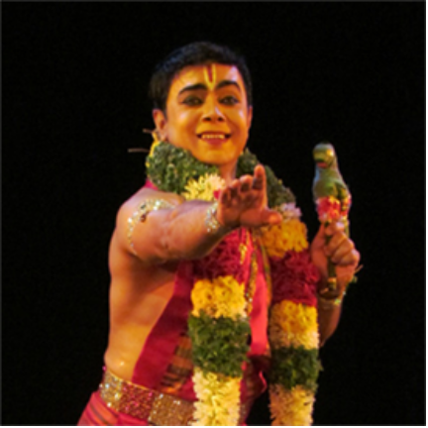  Zakir Hussain, a devoted Bharatanatyam dancer and a devotee of Andal, performed with utmost reverence, grace and sincerity. With select poetry of Andal, he personified her, seeing through her eyes - the Garuda Vahana that carries her lord, and the conch so close to his lips, or the floral garland that she tenderly feels before offering it to her lord, and finally the grand dream wedding and majestic elephant processions… Zakir delved into these symbols and messages that Andal draws on to express her love and deep desires. With a refined expressional and pure dance, the artist and Vaishnava scholar said it all – ‘Vanamaalai- the garland of love.’  Of jeevaatmas and paramaatma…  Earlier in the evening, Meenakshi Chitharanjan in the established aesthetics of Bharatanatyam, with pure and expressional dance performed to select compositions of Saint Thirunavakkarasar. The devotee as a lover is the female embodiment longing for her lord Shiva. The danseuse dramatized temple rituals and fanfare processions, the lord and his attributes… finishing off with the devotee’s surrender to the supernatural.  Photos: Lalitha Venkat  *****  SNIPPETS  Tim Rayborn, Ph.D., an initiate of the Order of Bards, Ovates & Druids & author of several articles on religious chant, feels that the feminine energy is especially valuable now. "When you study the women mystics," says Rayborn, "you can see that their visions were joyful and ecstatic. Male mystics, however wise, seem to focus more on suffering." He cites St. Augustine, St. Jerome, and St. John of the Cross. Rayborn feels that during the current transition, optimism will prove far more valuable than fear.  (‘Women Mystics and the New Millennium’ by Mary Devlin)  YESHE TSOGYAL  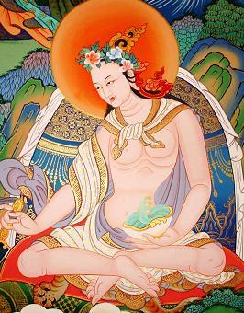  Born in the 8th century, Yeshe Tsogyal was a Tibetan princess who through her relationship with Padmasambhava, the Indian master who brought Buddhism to Tibet, became an enlightened Buddhist
www.kartikfinearts.com  www.narthaki.com  www.arangham.com |  | kartikfinearts@gmail.com  narthakionline@gmail.com
teacher and the most revered female figure in Tibetan Buddhism. She is also considered a dakini, or female deity of enlightenment. The Nyingma and Kagyu lineages of Tibetan Buddhism revere her as a female Buddha, and in fact she is often considered a reincarnation of the Buddha’s birth mother Maya. She is also sometimes referred to as the 'Great Bliss Queen.'  Most of what we know about Yeshe Tsogyal comes from her spiritual autobiography ‘Lady of the Lotus Born.’ Yeshe had spiritual leanings from birth, and begged to be allowed to study with Padmasambhava. The king agreed and released her from his kingdom. She became a spiritual consort to Padmasambhava. Consort-ship is a formal teacher/student relationship practiced within some Tantric Buddhist and Tantric Hindu sects in which the student's spiritual progress is accelerated through many occult forms of empowerment, including sexual practices.  Although Padmasambhava is reported to have had many such consorts, Yeshe is his most famous. She made fast progress on the path Padmasambhava set forth for her, which included long solitary retreats and intense meditations. She eventually became a revered teacher and master in her own right.  Yeshe had a magical memory, and thus Padmasambhava entrusted her with secret teachings and empowerments, referred to as 'termas.' She hid these termas around Tibet to be found by later generations.  MACHIG LABDRON  Machig Labdron is one of the most well-known Tibetan Buddhist woman teachers and lineage holders. She lived in 11th c Tibet, and is considered a 'mindstream emanation' or rebirth of Yeshe Tsogyal, the first major female Tibetan teacher, and consort to Tibet's root guru, Padmasambhava.  Machig practiced and taught the Chod, a unique ritual-based practice for transforming the four inner 'demons' that inhibit enlightenment. The Tibetan form of Chod that Machig taught is unique both because it was established by a woman teacher, and because it is one of the few truly Tibetan-created practices, as opposed to being purely imported from India (although Chod did have Indian antecedents). After several years of monastic practice, she eventually left this order, married a fellow practitioner and raised several children. This also sets Machig apart from many of the other well-known historical female Tibetan mystics, as few had families.  There was initially doubt about the validity of Machig's adaptations. A delegation was sent from India to 'test' her. After a long debate with top Indian Buddhist pundits, and rousing support from her students, her form of Chod was certified as a valid Buddhist Tantric practice, the first such practice to be fully born on Tibetan soil.  "As long as there is attachment to ego, there are demons.  When there is no more attachment to ego,  There are no more demons either!"  HANNAH RACHEL VERBERMACHER  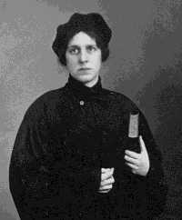  Hannah Rachel Verbermacher, also known as ‘the maiden of Ludmir’ was a 19th c Hasidic Jewish woman popularly known as the only female Hasidic Rebbe or religious leader, although she was never officially accorded that status. Believing his daughter had special spiritual gifts, her father provided her with a religious education unusual for girls of her time, including intense study of the Torah. She refused to marry and shaped an unusual life for herself as a spiritual counselor to many people, mostly women, within her Ukrainian community.  She lived alone in a small hut, engaged in Talmudic study and in Kabbalistic mystic practices usually reserved only for Hasidic men. On the Sabbath, she would give religious discourses through a small window. Over time, she developed a reputation, and people would travel from all over Eastern Europe to hear her discourses, receive blessings, or ask for advice or healings.  Eventually Hannah migrated to Israel, and attracted a new small group of devoted followers. She is buried on the Mount of Olives. | BAHINABAI  Bahinabai (1628-1700 AD), a Varkari female saint from Maharashtra, is considered a disciple of another  Varkari poet saint Tukaram. Unlike most female-saints who never married or renounced their married life for God, Bahinabai remained married her entire life. She reports being subjected to verbal and physical abuse by her husband, who despised her spiritual inclination but who finally accepted her chosen path of devotion. Her poetry mirrors her compromise between her devotion to her husband and God.  Bahinabai's abhanga compositions, written in Marathi, focus on her troubled marital life and the regret being born a woman as she was kept away from the knowledge of the holy scriptures like Vedas and sacred mantras by the male-dominated Brahmin society. Bahinabai sings in her abhang:  The Vedas cry aloud, the Puranas shout  "No good may come to woman."  I was born with a woman's body  How am I to attain Truth?  "They are foolish, seductive and deceptive -  Any connection with a woman is disastrous."  Bahina says, "If a woman's body is so harmful,  How in this world will I reach Truth?"  Bahinabai's abhangas call out to her god Vithoba (Panduranga, Hari) to help her to balance her twin  roles. Bahinabai's wisdom can be summed up in her words as: "A woman's body is a body controlled by somebody else. Therefore the path of renunciation is not open to her." Her philosophy reveals the social status of the 17th c Indian woman, who was supposed to have no existence apart from her husband. She has also composed a text called Pundalika-Mahatmya, which details the legend of Vithoba and devotee Pundalik, a central figure in Varkari tradition.  Bridal mysticism  The soul in the practice and experience of bridal mysticism goes through the harrowing experience of separation from HIM (Vislesham) and the exhilarating experience of union (Samslesham) with HIM. In Professor PN Srinivasachari’s words, “For them, Vislesha appears to be stretched into eternity and in Samslesha , the eternity is crowded into a moment.”  SUN BUER  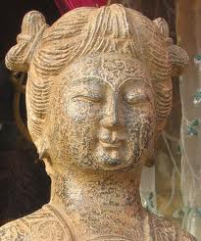  Sun Buer was a 12th-c Chinese woman, born into wealth and reportedly very beautiful. She married and raised 3 children. When her husband began to study with a famous Taoist master, Sun Buer was not all that interested, but at 51 she decided to leave her husband and grown children, to continue her own studies, and as a result became one of the few female Taoist ‘Immortals’ – a title representing both spiritual realization and occult mastery. She became a teacher herself with a considerable following, including many women, and founded the Taoist lineage know as the ‘Purity and Tranquility’ tradition.  Before our body existed,  One energy was already there.  Like jade, more lustrous as it’s polished,  Like gold, brighter as it’s refined.  Sweep clear the ocean of birth and death,  Stay firm by the door of total mastery.  A particle at the point of open awareness,  The gentle firing is warm.  Many of Sun Buer’s poems utilize symbols representing energy structures or flows that she studied. For example, in the poem above she is likely referring to energy center or chakra work when she refers to ‘polishing’ and ‘refining’, and the colors jade and gold. ‘Stay firm by the doorway’ likely refers to the root chakra, while ‘the point of open awareness’ is likely the third eye or crown. The ‘gentle firing’ is the smooth flow of kundalini that should occur when one is meditating properly on these energy centers. | MUGAI NYODAI  Mugai Nyodai was a 13th-c Japanese Buddhist nun credited with becoming the first Zen Buddhist Abbess. She was born into the Japanese warrior class & given the childhood name of Chiyono. She married and had a daughter at a young age. At some point, she began to visit the monastery of the Chinese Rinzai Zen monk Wu-hsueh Tsu-yuan (known in Japan as Mugaku Sogen.) Although laywomen were not commonly admitted to monasteries at the time, dharma custom assured that any woman who sought Buddhist teachings would receive them. Once Mugai's husband died and her daughter was grown, she became determined to live out the rest of her life as a nun. She shaved her head, gave up all her belongings, and showed up at the doorstep of Wu-hsueh Tsu-yun's monastery, taking the name Mugai Nyodai as part of her monastic vows.  Here is a translation of her poem from the classic Zen Flesh, Zen Bones by Paul Reps and Nyogen Senzaki:  In this way and that I tried to save the old pail  Since the bamboo strip was weakening and about to break  Until at last the bottom fell out.  No more water in the pail!  No more moon in the water!  When Wu-hsueh Tsu-yun died, he named Mugai his successor, but this met with some resistance by the monks. Over time, she prevailed and founded the Keiaiji Convent, head temple complex of the Five Mountain Rinzai Zen Convent Association. As was tradition at the time for all monastic leaders, a statue was made of her with shaved head and monk's robes. It is now considered a historical treasure of Japan, and is kept in the Hojiin convent in Kyoto.  HILDEGARD OF BINGEN  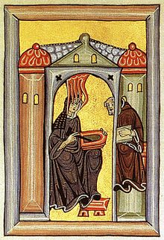  Hildegard of Bingen (1098-1179) lived a withdrawn life, spending most of her time behind convent walls. Also known as Saint Hildegard, and Sibyl of the Rhine, she was a writer, composer, philosopher, Christian mystic, German Benedictine abbess, visionary, and polymath. Elected a magistra by her fellow nuns in 1136, she founded the monasteries of Rupertsberg in 1150 and Eibingen in 1165. One of her works as a composer, the Ordo Virtutum, is an early example of liturgical drama. She wrote theological, botanical and medicinal texts, as well as letters, liturgical songs, poems, and arguably the oldest surviving morality play, while supervising brilliant miniature Illuminations.  Hildegard says that she first saw ‘The shade of the living light’ at the age of 3, and by the age of 5 she began to understand that she was experiencing visions. Hildegard explained that she saw all things in the light of God through the five senses: sight, hearing, taste, smell, and touch. Throughout her life, she continued to have many visions, and in 1141, at the age of 42, Hildegard received a vision she believed to be an instruction from God, to "write down that which you see and hear." Still hesitant to record her visions, she became physically ill. The illustrations recorded in the book of Scivias were visions that Hildegard experienced, causing her great suffering and tribulations.  Her writings, poetry and music were revelatory for the time period. She was consulted by Popes, Kings and influential people of the time. She appears in the calendar of saints in various Anglican churches. In the Church of England she is commemorated on Sept 17. In space, she is commemorated by the asteroid 898 Hildegard.  Interviews by Lalitha Venkat  Info compiled by Lalitha Venkat  Source: Internet

